Pillars in the Recessed Portico in the Roya Gopuram with the Base of One of the Four Sculptured Monoliths, Madura
Linnaeus Tripe | January–March 1858 | Record IMG-SA0004

1. Original Image
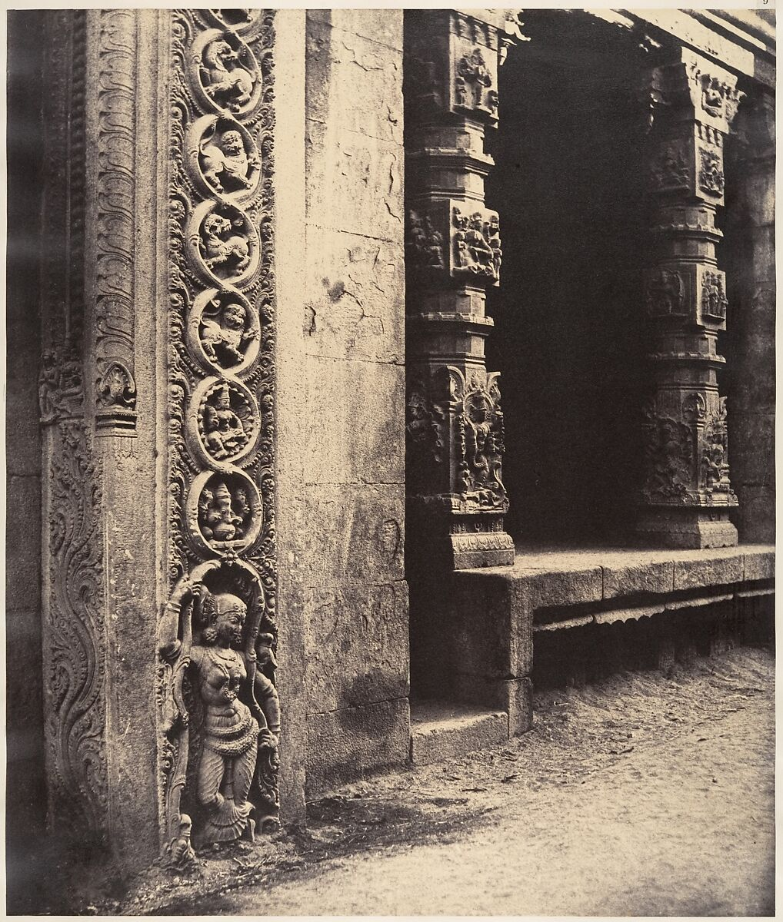

IMG-SA0004. Pillars in the Recessed Portico in the Roya Gopuram with the Base of One of the Four Sculptured Monoliths, Madura, Linnaeus Tripe (British, Devonport (Plymouth Dock) 1822–1902 Devonport), January–March 1858, Albumen silver print from waxed paper negative, Image: 35.8 x 30.2 cm (14 1/8 x 11 7/8 in.), Mount: 45.3 x 57.5 cm (17 13/16 x 22 5/8 in.)

2. Record Summary
Record ID | IMG-SA0004
Original title | Pillars in the Recessed Portico in the Roya Gopuram with the Base of One of the Four Sculptured Monoliths, Madura
English title | Pillars in the Recessed Portico in the Roya Gopuram with the Base of One of the Four Sculptured Monoliths, Madura
Alternative title | N/A
Creator | Linnaeus Tripe
Creation date | January–March 1858
Country | India
Cultural region | South Asia; Madurai
Historical period | Nineteenth-century British colonial India; architectural survey photography
Image type | Photography
Medium | Albumen silver print from waxed paper negative
Dimensions | Image: 35.8 × 30.2 cm; mount: 45.3 × 57.5 cm
Primary subject | Carved stone pillar in a portico
Secondary subjects | Columns, brackets, relief sculpture and architectural openings
Source institution | The Metropolitan Museum of Art
Collection or object number (optional) | 2005.100.381.1.9

3. Image Description

3.1 Short Description
A vertical architectural photograph focuses on a large carved stone pillar at the left edge of a recessed portico. Circular and figural reliefs run down its surface. Additional columns, brackets and dark openings recede to the right, while a rough stone floor occupies the foreground.

3.2 Detailed Visual Description
A massive vertical pillar dominates the left foreground and is cropped by the upper and left edges. Its surface contains stacked ornamental bands and a standing sculpted figure near the base. Behind it, a narrow bright wall separates the foreground element from a deeply shadowed recess.
Several square columns and projecting brackets create repeated vertical and horizontal forms across the middle and right portions of the image. Some surfaces contain shallow carving; others appear worn and irregular. A low stone platform extends from the recessed area. The foreground consists of a rough, pale stone or packed-earth surface. Strong sunlight strikes exterior stone faces, while interior openings appear nearly black. No people, animals, plants or legible written text are visible.

4. Formal Features
Field | Analysis
Composition | A dominant foreground pillar is balanced by receding columns and openings.
Viewpoint or camera angle | Approximately torso height, facing the sitter directly.
Shot scale | Medium-wide architectural detail.
Spatial depth | Repeated columns and dark recesses produce strong recession.
Lighting | Bright exterior daylight and deep interior shadow.
Colour palette | Warm monochrome brown, cream and black.
Contrast | Strong light-dark contrast.
Visual focus | The decorated foreground pillar.
Texture | Carved, worn and rough stone surfaces.
Movement or stillness | Completely still architectural subject.
Medium-specific features | The waxed paper negative produces detailed but slightly softened stone textures.

5. Historical Context and Purpose

5.1 Historical Context
Tripe was a military officer and Government Photographer to the Madras Presidency. In early 1858, he undertook a government-supported tour to document architecture, antiquities and sites in southern India. The Met identifies the subject as carved pillars associated with the gateway of the Meenakshi Sundareshvara temple in Madurai and records that the photograph formed part of Photographic Views in Madura. [IMG-0003-S01] Image Purpose and Circulation

5.2 Image Purpose and Circulation
Verified original purpose: Government-supported architectural and antiquarian documentation.
Current institutional use: Preservation as both an architectural record and an example of early photography in India.
Because the subject belongs to an active religious and cultural heritage site, dataset use should retain the site name and avoid treating the architecture as an anonymous decorative pattern.

